LIFE-BECKON
Boosting Energy Communities massive deployment by equipping local authorities with comprehensive technical assistance cooKboOk, integrated services and capacity buildiNg

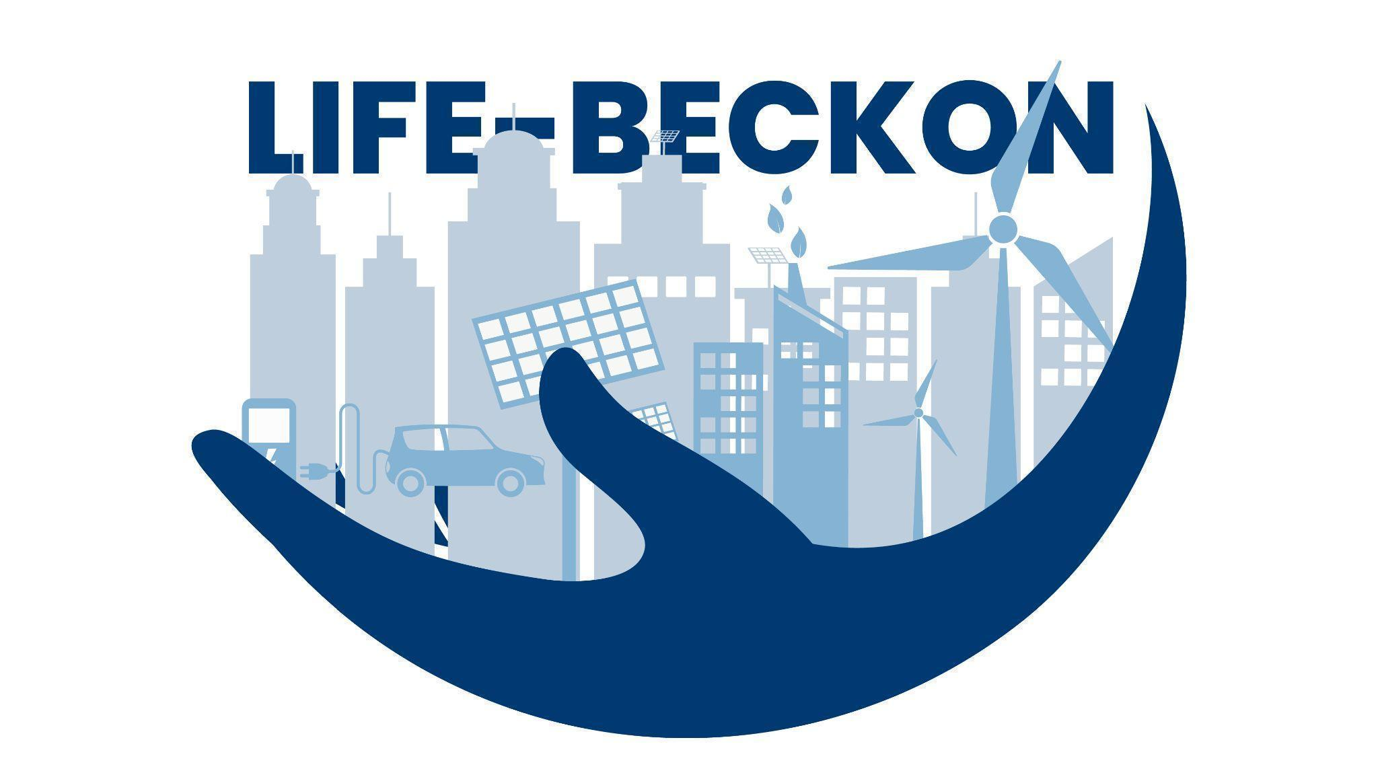

Grant Agreement: 101076765

Business Plan Template

Author: Asier Larretxea Barja (WEG)

This document outlines the main chapters a business plan should contain for an Energy Community. The chapters of this document will be developed based on the outcomes derived from the various stages outlined in the Design Phase of the Guidance Hub, as established by the LIFE-BECKON Project, or analogous tools and supplementary resources. May 2025

DISCLAIMER
Co-funded by the European Union. Views and opinions expressed are however those of the author(s) only and do not necessarily reflect those of the European Union or CINEA. Neither the European Union nor the granting authority can be held responsible for them.

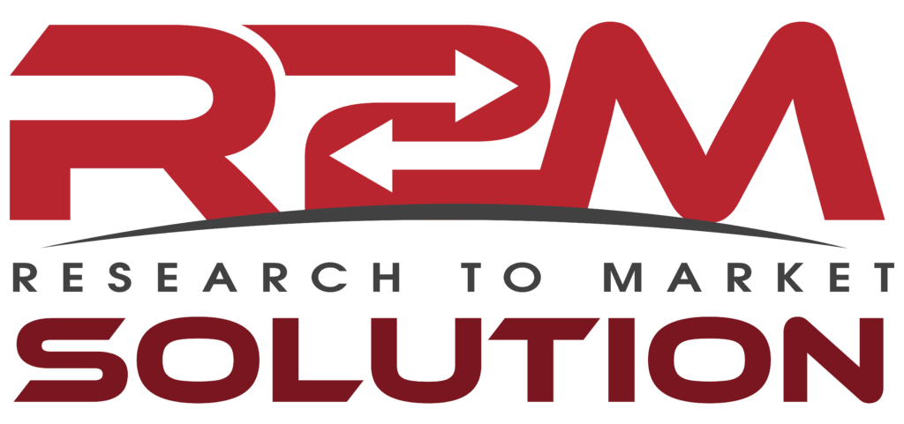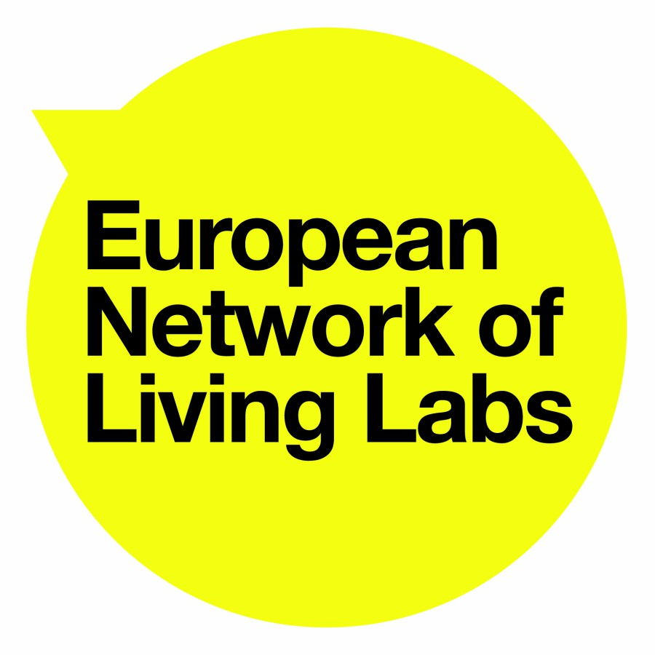


INSTRUCTIONS TO USE THE BUSINESS PLAN TEMPLATE

This business plan template helps the user define the different sections of a business plan for energy communities. The instructions give several tips of what is important to be included in the business plan. Please, feel free to modify and adapt the business plan template in the most convenient way.

In order to facilitate the fill in of this business plan template, the user is invited to use other material described in the Guidance Hub of the LIFE-BECKON project “design phase”, related to each of the sections of this Business plan template.

In case you are just starting and new in the topic, consider using ”Two pager summing up the initial idea for Energy communities' ' from the “initiation” phase. This document helps discuss and define the key ideas for the ECs. You may also find it helpful to consult the videos.

Table of contents

1. Executive Summary 4
2. EC Concept 5
3. Business Model 8
4. Engagement strategy, communication & participatory processes 10
5. Governance and Staffing 12
6. Financials of the project 13
7. Evaluation 15
8. Appendices 17

Executive Summary
Shortly explain the main facts about the business plan. The summary should at least briefly explain:
- The goal of the EC.
- The activities performed.
- The promoters and expected participants.
- The benefits and USPs for the potential participants, collaborators and investors.
- How it will be organised.
- The funding & revenues and the investments & costs.
This section should only be completed once the business plan is written.

Keep in mind that potential supporters and investors often first check the executive summary to recognize the potential interest, before they read the business plan into detail

EC Concept
Current context
- Describe the initial stage. This means defining the current projects related to Energy Communities (if any), infrastructure available, resources, etc.
The EC Concept
- Definition of goals and scope of the energy communities.
  - Define the long-term vision of the Energy Community.
  - State the objectives to be achieved during the first years of the Energy Community.
    - Fight against climate change
    - Invest in clean energy
    - Reduce energy use
    - Reduce energy costs
    - Fight against energy poverty
    - Support local economy
    - Other:
- Select the activities related to energy and projects expected to be carried out by the energy community.
  - Electricity generation & self-consumption:
    - Collective self-consumption based on PV.
    - Collective self-consumption project based on other resources (hydropower, wind power, biogas plants, etc.).
  - Generation of electricity (PV, wind, hydro, etc., but not for self-consumption).
  - Collective self-consumption of heat (solar thermal, biomass boiler, DHC, etc.).
  - Collective contracting of electricity supply (or gas, fuels,etc).
  - Collective purchase of energy efficiency measures.
  - Retrofitting of buildings/neighbourhoods.
  - Electricity grid operation.
  - Supply (creation of a utility).
  - Flexibility (service provisions to the grid).
  - Transport & mobility:
    - EV charging infrastructure.
    - Shared mobility initiatives (bicycles and/or scooters, cars).
  - Others:

Find supporting material in the “define the concept” section. You will get material to describe the main goals and characteristics of ECs, and a selection of potential activities related to energy that the EC can perform.

Identification of Key actors involved
- Definition of key actors, their roles, and responsibilities in terms of legal practices. These actors can directly participate in the EC, provide support or be relevant in the future activity of the EC.
Find supporting material in the “Define key actors, their roles and responsibilities” section.

Legal context and type of legal entity
- Description of legal context and regulatory of the energy of communities
Find supporting material providing legal context for Denmark, Bulgaria and Spain in section 2.4.1. Description of legal and regulatory context of energy communities for BG, DK, SP. In addition, an overview of the European legislation is facilitated.

Legal entity
- Selection of the type of legal entity of the energy community (association, cooperative, etc.).

Find supporting material in section 2.4.2. election of type of legal entity.

Description of the activities, products and services
Once the activities and projects are identified, explain clearly the products or services and what they will do.
- Describe the context
- Describe the service or product developed.
- Describe the USP (unique selling point) and the advantages.
- Describe who does what: What each partner provides, how they get rewarded, etc.
- Future developments

Note that at this stage, the goal is to identify the key elements of the activities and projects. More description about each of the activities and projects expected can and should be described in the annexes.

Business Model
This section describes how the business model behind the activities of the Energy Community works. The business can be owned either by the community, or divided through stakes between different stakeholders.
Business organisation
Describe how the activities (products / services provided) benefit each of the key stakeholders. This could include tax benefits and capital cost advantages, individual investor gains, potential feed-in-tariff and the viability of the project. Describe any lease agreements and advantages over competitors as well as potential local authority/ municipal partnerships.
(Make a diagram if possible).
Value Proposition to individuals and community groups
Describe the benefits of membership of the organisation. These benefits might be financial (cost savings, tax deductions), social (fighting the energy poverty, increasing the community cohesion), or environmental (reducing the carbon footprint, etc.
Value proposition to other participants,
Describe the benefits of the business for other participants such as financial investors, support partners (public administration, etc.). These benefits might be financial, social, legal and environmental, etc.
Resources required
Describe the resources necessary for the EC in order to perform the activities, services and products identified.
This includes various areas, such as:
- Internal resources: Human resources (voluntary or in a payroll).
- Infrastructure and investment requirements.
- External resources and Subcontracted services (installation company, EC manager, engagement and communication costs, investment costs, maintenance and operation, customer services, etc.)

Pricing
It is fundamental to define how you will set the price charged for your product or service. Considerations include:
- Competitors’ prices and general market prices
- The capability to pay from the participants
- Perception of quality-price relationship by participants
- Production costs and overheads
- Chain of distribution and the added-value at each stage
- The extent to which the buyer can control the price

State how each product or service will be priced, referring to the income sources above

Engagement strategy, communication & participatory processes
Engagement strategy
Energy communities, by definition, are based on the wide representation and participation of the different stakeholders involved. Therefore, the correct engagement of the potential stakeholders interested is fundamental.
While in traditional business models, the marketing/sales strategies are fundamental, in Energy Communities, the goal is not to sell something, but really to make the stakeholders active participants of the project (becoming members), or at least, attract the interest of other stakeholders (such us the interest of potential investors and other supporters).
This engagement process should take into consideration 2 different phases, despite these phases sometimes might be interlinked.
- Initial engagement, where the main goal is that the initiators of the project attract the critical mass of stakeholders and make them part of the design of the ECs and the projects.
- Follow up engagement, taking place once the EC and the activities/projects are decided but still it is necessary to attract new stakeholders, such as new investors, potential consumers/customers of the defined activities, etc.
In both cases, designing the right engagement strategies and using the correct tools for it will be fundamental.
Marketing and communications strategy
Decide how you will position your energy community and the products and services provided to the potential partners:
- Which segments of the market will be targeted first and why – (eg. shareholder members/ potential members/ partners and potential partners as well as funders and beneficiaries of fuel poverty alleviation programmes)
- What key benefits will be highlighted? What is special about the project?
- What potential customers have you already targeted?
- Do you have a test site in operation, and what feedback is coming from this?
- What contacts can be used to generate market awareness and sales?
- Who will do the marketing: staff, agency, reps? >>

Decide how you will promote the EC, the products and the services:
- Advertising – where, when, how, to whom
- Public relations
- Direct marketing
- Website and internet marketing
- Exhibitions and conferences
- Word of mouth >>

Find supporting material for the engagement strategy in section 2.1 Engagement: and Communication

Participatory process
In addition to the engagement process, securing the active participation of the relevant stakeholders during the definition of the project, as well as during the lifetime of the energy community and its projects will be fundamental. This will ensure the democratic character of their structure.
In this section, define how the processes for participation in the decision making processes will be defined.
Find supporting material for the participatory process in section 2.1 Engagement: and Communication

Governance and Staffing
This is the section where you will outline the intended structure of the Energy Community, in terms of management, number of employees, skills, experience, training and retention and the physical operational requirements.
Management & Governance
Include a diagram of the way in which the management of EC will be organised. This should show the areas of responsibility of each manager and the employees/volunteers to be taken on over the next three years.
Take into consideration that the Governance structure will be conditioned by the type of legal entity we are selecting (cooperative, association, commercial company, etc.).
Find supporting material for the definition of the governance in the section 2.1 Engagement: and Communication

The diagram should take into consideration:
- The directors.
- The membership agreements.
- The staff and voluntary positions in the company.
- The advisors and external collaborators
- The skills, experience and training necessary for each of the participants described.

Financials of the project
Financing the Energy Community and the projects
Identify and describe in detail the way the EC and the related projects will be financed/funded. Here we find different alternatives.
- Grant Aid
- Loans
- Energy Service Company (ESCO)
- Community Shares
- Energy feed-In-Tariff (REFIT)
- Tax Incentives
- Green Bonds
- Community buy-in to commercial project
- Social return – Sustainability Fund>>

Find more detailed information on how to finance an Energy Community project in “2.4.4. Financing models for ECs. There, you will find detailed information and examples on the models, instruments and EU funding opportunities, among others”.

Find supporting material on financial support programs in Denmark, Bulgaria and Spain in section “2.4.5. Identification of support programs for ECs and PV installations in the countries of interest (financial/tax levies, grants, etc.)”

In addition to the financing of the projects, it is important to consider other incomes coming from the fees of participating in the energy community as well as the incomes produced due to the delivery of products and services. These products and services can be provided to the EC participants, as well as to external citizens and organisations.

Identifying Investments and costs
Based on the resources named in the Business Strategy section, identify the investments and costs the Energy community and the activity to be performed will suppose. This included: The infrastructure, the staff, the subcontracted services (installers, maintenance and operation, etc.).
Financial projections
Once the financing sources and incomes on one hand, and the investment & costs on the other are clear, it is important to make projections of the financial balances, at least of the first years (investments and first 5 years of operation).
The financial projections should at least, include the following steps:
- Define the key assumptions used for the financial projections
It is important to explain what was considered and how key figures in the financial projections were arrived at. This might include concepts such as:
- Income sources
- Number of employees projected for each year and their intended salaries
- Projected investment in equipment and materials
- Projected R&D costs
- Depreciation allowed for
- Expected rent and rates charges
- Creditor days expected and debtor days allowed
- Expense calculations

Please, keep it simple. In case you need to add more information, do so in the appendixes.
- Accounts of profits and losses
Include here the projected profit and loss accounts for the 5 years of energy community operation.
- Balance Sheets
Include the balance sheets for the first 5 years of the energy community operation.
- Cashflows
It is important to keep a track of the cash flows expected. Therefore, include the expected cash flows per month, in the first 3 years of operation of the Energy Community.
Find supporting material regarding tools to make calculations of the financial projections and the feasibility of the energy community and the energy projects in section “2.4.6. Feasibility of the project”

Evaluation
Evaluating the business proposal of the energy community will be fundamental. This process will:
- On one hand, secure robustness of the proposal and prepare mitigation measures;
- On the other, provide certainty and trust to potential participants, collaborators and investors.
In order to do so, next, some of the most commonly used evaluation processes are provided:
Find supporting material regarding evaluation tools and processes in the section “2.4.7. Evaluation”.

Evaluation of strengths and weaknesses (SWOT analysis).
Use of a swot (strengths, weaknesses, opportunities and threats).

Socio-Economic evaluation (ESAP template)
This is an evaluation more and more commonly used by investors and public organisations to evaluate the value of proposals.
Risk Assessment & Critical Success Factors
Using these processes will allow you to provide information on the potential risks involved in the project, the impact and probability of such risk and ways in which to mitigate the risk. The section will also analyse the factors involved in the success of the project.
RISK | IMPACT  High/Medium/Low | PROBABILITY  High/Medium/Low | MITIGATION

Appendixes
The appendices section is used to provide the detailed data and to provide extra information of interest to the readers of the business plan. Items for inclusion in appendices can vary considerably. Some examples of appendices are the following:
- Detailed description of the business strategy.
- Detailed financial assumptions,
- List of agreements and commitments got already
- Most recent Company Audited Accounts,
- Share Cap table and Investment history,
- Literature,
- Activity, product and service information.
- Details of the legal context.
- Testimonials or letters of intent from customers.
- Details of engagement and marketing material (website, digital announcements, etc.).
- List of actions carried out (meetings, webinars, communication campaigns, etc.).

